Q1.

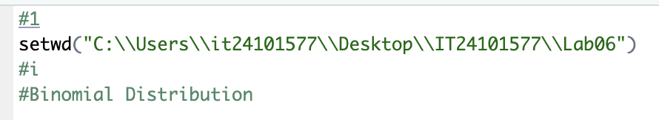

1. Binomial Distribution
2. A number of numbers on a white background

   Description automatically generated

Q2.

1. Number of customer calls received per hour
2. Poisson distribution
3. 

